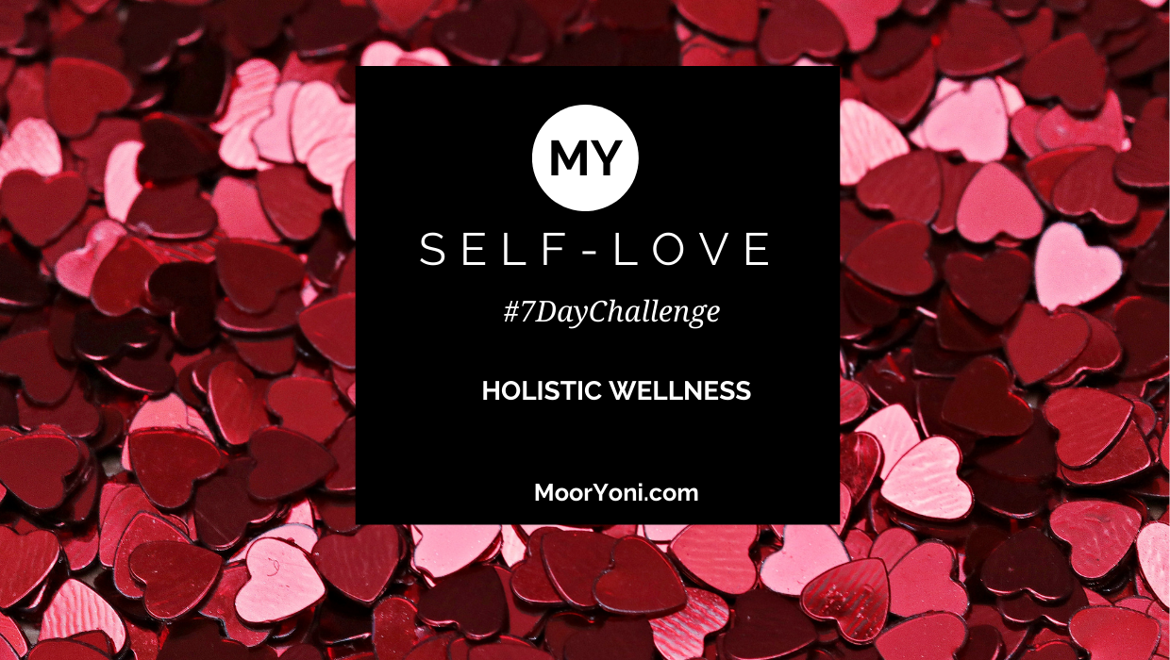

Day 1 - 7 Day Journey to Self-Love

“Learning to love yourself is the greatest love of all.”
Michael Masser

Q What does love mean to you?
(Observe and notice any emotions, feelings or sensations that may occur during your reflections)

Q When was the last time you felt loved? Have you ever experienced unconditional love?
(How did you feel…Is there a difference)

Q How will you know when you have been successful in your self-love journey?
Describe the behaviours/actions/change/feeling…

** Create a declaration of love to yourself – e.g. I will, start, learn, be, do, more… sign and date. (Get creative by writing this and placing it where it is visible it along with an affirmation.)

Day 2 - 7 Day Journey to Self-Love

A limiting belief is a state of mind, conviction, or belief that you think to be true that limits you in some way. e.g. ‘I am bad at relationships’, ‘I am not worthy of love’

Q What are your beliefs about love?
(Are any of these beliefs not helping you? Observe and notice any feelings)

Q Have there been any scenarios where you have knowingly behaved in a toxic, irrational or negative way?
(e.g. self/relationships/romantic/friends. What were your reasons in relation to your belief…)

Q Alternatively are there any areas in your life/relationships where you have recurring challenges?
(Are these linked to any limiting beliefs?)

** Begin to observe any negative self-talk or self-criticism e.g. I am rubbish, I am stupid, I am no good. Pay a penalty of £1! Stop labelling yourself, remember your subconscious detects everything.

Day 3 - 7 Day Journey to Self-Love

Today we honour our heart and allow the love to flow freely

Q Write a love letter to yourself…

Q Give more love & receive more love…(e.g. by compliments, smiling, gratitude, appreciation, forgiveness). Describe the feelings.

Q What is your favourite love or ‘happy’ song and why?

** Enjoy or experience some air, either walking in a park, open space or breathing some air through the window or doing breathe work.

Day 4 - 7 Day Journey to Self-Love

I forgive others and I forgive myself

Q What did you learn/witness about love from your parents/caregivers …

Q Do you remember your first crush or the first time you were ‘in love’?

Q Describe your first heart break? What love lessons did you learn?

** Write down any past hurts/pain or beliefs from previous relationships you feel you maybe still be holding on to…are they preventing the flow and abundance of self-love?

Day 5 - 7 Day Journey to Self-Love

I am worthy and deserve love

Q When was the last time you pampered yourself? What did it involve…?

Q What do you do to pick yourself up when you are feeling down/low?

Q Who do you go to when you need, support, motivation or a boost?

** Write down 5 things you physically like about yourself, 5 things you like about your personality and 5 things you like about your life.

Day 6 - 7 Day Journey to Self-Love

Love is never about possessing but letting go

Q What are your beliefs about love? What have you learnt from parents, culture, your own experiences? What do you need to let go of?

Q How self-aware are you about what you need in relation to yourself and your relationship with others? What is your love need? What is your love language?

Q How confident are you at asserting yourself, your boundaries? When was the last time you had to do that? What was the outcome?

** List your Bill of Rights – the things you will not accept, your values, boundaries, your standards in relation to others and yourself.

Day 7 - 7 Day Journey to Self-Love

I Love Me

Q Like any goal, its important to set a clear intention & have a plan to ensure maximum success. Set a list of self-love SMART goals…

Q What challenges may you experience? What will be your contingency plan?

Q How will you know when you have been successful? What will you feel, do, be or have…

** Assess your support network – how balanced is your support network?
Who inspires you…. motivates you…comforts you…keeps you on track…

